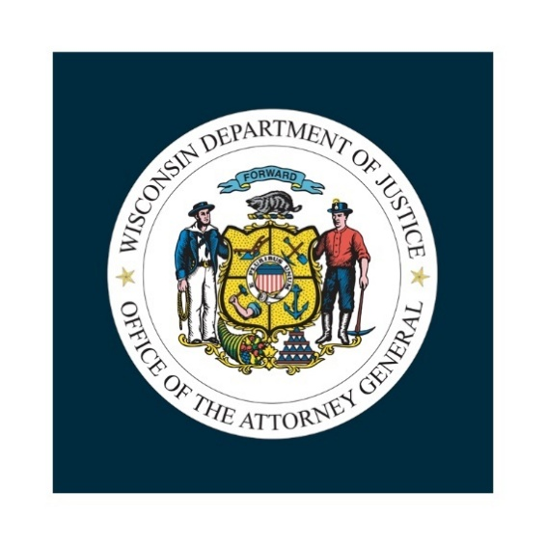
Wisconsin Department of Justice
Bureau of Justice Programs

Contact: Sabrina Gentile, (608) 287-4310, Sabrina.Gentile@wisdoj.gov

County Tribal Law Enforcement Services
County/Tribal Law Enforcement Assistance 2027

Grant Announcement

Pre-Applications must be submitted by October 2, 2026.
Applications must be submitted by November 13, 2026.

Grant Title: County/Tribal Law Enforcement Assistance 2027
Description: Wis. Stat. § 165.90 creates the county/tribal law enforcement assistance grant program.

Important Dates:
Pre-Application Due Date: October 2, 2026
Award Amount Certification Date: October 19, 2026
Application Due Date: November 13, 2026
Award Amounts Sent: By January 15, 2027
Project Start Date: January 1, 2027
Project End Date: December 31, 2027

Match Requirement: None

Eligibility: Any county that has a federally recognized Reservation or Off-Reservation Trust Lands within its boundaries may enter into an agreement in accordance with Wis. Stat. § 59.54(12) with the Indian tribe located in the county to establish a cooperative county-tribal law enforcement program. A County or Tribe may be an applicant for any number of awards.

Eligible Expenses: Funding may be used to fund county law enforcement operations. Please feel free to contact the Wisconsin Department of Justice (DOJ) with any questions about allowable expenses.

Program Contact: Sabrina Gentile, (608) 287-4310
Sabrina.Gentile@wisdoj.gov

County/Tribal Law Enforcement Assistance 2027
Pre-Application Review
Anticipated Funding Amount: Under Wis. Stat. § 20.455(2)(kt), there is no cap on a single award and the total available funding for all grants is $631,200.
Award Calculation: The DOJ utilizes a formula process in making awards. The DOJ equally considers reservation population in relation to county population, the county violent crime rate, and the tribal unemployment rate.

Preliminary Data: See Next Page

Source Documents:
- Population data is provided by the FBI, and based on the U.S. Census Bureau's Population Estimates
- Tribal Data - Source 2020-2024 American Community Survey 5-Year Estimates, U.S. Census Bureau
- WI DWD 6/2026 County Non-Seasonally Adjusted Unemployment Rate
- Violent Crime rate is # per 100,000 residents calculated by WI DOJ BJIA

Pre-Application Process: Each county/tribe program interested in applying needs to notify the DOJ of their intention to apply. If the DOJ receives no response by October 2, 2026, the program may not be allotted funds. The DOJ has collected preliminary data on past applicants for their review. If an applicant is applying for the first time, please search the source documents for preliminary data. If the applicant thinks there is a discrepancy with the preliminary data, an applicant can provide the DOJ with a proposed value with justification in their pre-application response for review by the DOJ.

Due Date: Pre-application responses are due to the DOJ at Sabrina.Gentile@wisdoj.gov by October 2, 2026. The DOJ will review each applicant’s eligibility and will provide each applicant with their final award amount by October 19, 2026.

Preliminary Data:

Past Tribal and County Applicants | Reservation/  County Population | County Violent Crime Rate | Reservation  Unemployment
Bad River Band of Lake Superior Chippewa Indians | 1,279 |  | 4.7%
Forest County Potawatomi Community | 667 |  | 12.6%
Ho Chunk Nation | 1,131 |  | 15.2%
Lac Courte Oreilles Band of Lake Superior Chippewa Indians | 3046 |  | 9.2%
Lac du Flambeau Band of Lake Superior Chippewa Indians | 3,654 |  | 10%
Menominee Indian Tribe of Wisconsin | 3,548 |  | 12%
Oneida Nation | 27,624 |  | 2.6%
Red Cliff Band of Lake Superior Chippewa Indians | 1,256 |  | 12.5%
St. Croix Chippewa Community | 447 |  | 9.9%
Sokaogon Chippewa Community in Mole Lake | 466 |  | 8.4%
Stockbridge-Munsee Mohican Community | 714 |  | 6.6%
Ashland County | 16,230 | 129.39
Barron County | 46,796 | 121.81
Bayfield County | 16,979 | 58.90
Brown County | 276,512 | 169.25
Burnett County | 17,330 | 126.95
Forest County | 9,586 | 239.93
Jackson County | 20,994 | 19.05
Juneau County | 26,521 | 361.98
Menominee County | 4,290 | 69.93
Monroe County | 46,352 | 194.17
Outagamie County | 205,329 | 141.72
Polk County | 45,999 | 84.78
Sauk County | 65,965 | 104.60
Sawyer County | 19,004 | 178.91
Shawano County | 41,146 | 99.65
Vilas County | 24,148 | 20.71
Wood County | 74,963 | 170.75

County/Tribal Law Enforcement Assistance 2027
Grant Application

Applications must be received by the DOJ via email or postmarked
by USPS on or before November 13, 2026.

Name of Applicant Agency | County: | Tribe:
Street Address
City
State
Zip Code

Signatory Name
Title
Street Address
City
State
Zip Code
Email

Program Contact Name
Title
Street Address
City
State
Zip Code
Email

Please make sure the following are attached and submitted with the application. If there are scheduling issues, please contact DOJ.
- County Board Resolution Approving Joint Plan

- Tribal Governing Body Resolution Approving Joint Plan

- 2026 Preliminary Grant Close Out Report (See page 8 of this package)

Budget Summary: Please enter the amount of expenses that are anticipated in each of these budget categories.

Personnel
Fringe
Travel
Equipment
Supplies
Other
Total | $

Budget Narrative: Please enter a justification that describes how the items in each category will be used during the course of the grant period and describe how your budget relates to the overall program.

Project Narrative: Narrative should include:
- A description of the proposed cooperative county/tribal law enforcement program for which funding is sought, including information on the population and geographic areas to be served by the program. A county board resolution approving the joint plan and a tribal governing board resolution approving the joint plan must be submitted.
- The program’s need for funding.
- The government unit that will administer the grant funding and the method by which the funding will be disbursed, including specifying the allocation of the aid between the tribe and county.
- Types of law enforcement services that will be performed on the reservation and the persons who will perform the services.
- The individual who will exercise daily supervision and control over law enforcement officers participating in the program.
- The method by which county and tribal input into program planning and implementation will be assured.
- The program’s policies regarding deputization, training, and insurance of law enforcement officers.
- The record keeping procedures and types of data to be collected by the program.

County/Tribal Law Enforcement Assistance 2027
Grant Modification Request

Instructions: During the term of the grant if there is a need for a modification to the approved application, please submit this completed document to the DOJ for review and approval.

Modification Narrative: Describe the need for the modification to the original application.

Budget Modification: Enter the changes to the budgeted amount in each category. If there is no movement of expenses between categories, leave this blank.

Personnel
Fringe
Travel
Equipment
Supplies
Other
Total | $

Budget Narrative: Please describe how the spending in each category will be modified.

County/Tribal Law Enforcement Assistance 2026
Preliminary Grant Close Out Report

Instructions: Under Wis. Stat. § 165.90(4)(b), each County/Tribal program needs to submit a final report. To be awarded funds, please submit a preliminary report by December 31, 2026, to be included in the DOJ program summary due to the legislature by January 15, 2027, as required under Wis. Stat. § 165.90(5).

Grant Use: Please describe some of the accomplishments of the program during the calendar year and how the award amount was used.

Final Expenses: Enter the amount in each category.

Personnel
Fringe
Travel
Equipment
Supplies
Other
Total | $
Pending Grant Activities: If any of the award amount has not been expended or encumbered, please describe a use and timeline for these funds.

